Open Educational Resources Training Platform (OERTP)
Software Project Management Plan
Release 2
Version 1

Raj Bharath Adamaram Seshadri

Contents
1. Introduction 5
1.1. Project overview 5
1.2. Project deliverables 5
1.3. Evolution of the SPMP 5
1.4. List of definitions 6
1.5. List of references 6
2. Project Organization 8
2.1. Process Model 8
2.2. Organizational Structure 9
2.3. Boundaries and Interfaces 9
2.4. Project responsibilities 10
3. Managerial Process 11
3.1. Objectives and Priorities 11
3.2. Assumptions, Dependencies and Constraints 11
3.3. Risk Management 11
3.4. Monitoring and Controlling Mechanisms 12
3.5 Staff Plan 13
4. Technical Process 14
4.1. Methods, Tools and Techniques 14
4.2. Software Documentation 14
4.3. Project Support Functions 14
4.3.1 Configuration Management 14
4.3.2 Quality Assurance 15
5. Work packages, Schedule, Budget 16
5.1. Work packages 16
5.3. Resource Requirements 17
5.4. Budget and Resource Allocation 18
5.5 Schedule 23
Appendix A: Design Phase 23
Appendix B: Development Phase 23
Appendix C: Testing Phase 23
Appendix E: Gantt chart 23
Appendix F: Work Breakdown Structure 29
Appendix G: Change log history 33

1. Introduction

1.1. Project overview
In the OERTP project a system has to be designed to work as a platform for accessing resources for educational and training purposes. The software made consists of at least three applications, which must interact using the internet. Dispatchers gather jobs from various Submitters and dispatch them to so called Agents. The entire system has been developed using Drupal 7 content management system framework in a way that it is easy to maintain and extended at UNESCO.

1.2. Project deliverables
During the course of the project, several documents have to be produced and delivered to the customer and to the SM. All these documents have to be written according to the [IEEE] and [ESA] software engineering standards. All products that will be delivered to the SM and/or the customer are mentioned in the table below, together with the phases for which they represent outputs. The project manager will send metrics to the SM on a basis of development of the project.

If there is a progress meeting, this information is delivered in a progress report, otherwise a metrics sheet is sent.

Phase | Deliverables | To Whom
Design Phase | SDDP, SRSP, SPMP, SRMP | SM
Development Phase | Software Product, SCMP | SM
Testing Phase | SQAP | SM
Feedback Phase | UM, Feedback record | UNESCO
Table1. Project Deliverables

1.3. Evolution of the SPMP
This document is subject to changes. The assumptions, dependencies and constraints for the project, the detailed time and resource planning for each phase (see appendices) can change during the project. Changes in this information will lead to a new SPMP with a new version number, but with the same status. However, if these changes lead to changes in the milestones planning of the project, described in section 5.5, these changes are discussed with the SM first, before they are incorporated in the document. This will be done during progress meetings. The detailed planning for each phase is described in the appendices of this document. These appendices are updated at different moments in time during the project, but before the start of the phase they refer to.

1.4. List of definitions

AD Architectural Design
SDDP Software Design Descriptions Plan
AT Acceptance Test
Client Monitor, Agent or Submitter
CM Configuration Management
Customer UNESCO.
DD Detailed Design
Dispatcher Application that dispatches jobs to Agents
IT Integration Test
PM Project Manager
QAM Quality Assurance Manager
SCMP Software Configuration Management Plan
SM Senior Management
SPMP Software Project Management Plan (this document)
SQA Software Quality Assurance
SQAP Software Quality Assurance Plan
SA System Analyst
SR Software Requirements
SRSP Software Requirements Specification Plan
STD Software Transfer Document
Submitter Application that submits jobs to dispatchers
SUM Software User Manual
TL Team Leader
TR Transfer Phase
UNESCO United Nations Educational, Scientific and Cultural Organization
UT Unit Test
UR User Requirements
UM User Manual
RM Risk Management
SRMP Software Risk Management Plan

1.5. List of references

[SPMP] Software Project Management Plan

[SCMP] Software Configuration Management Plan

[SRSP] Software Requirements Specification Plan

[SDDP] Software Design Descriptions Plan

[SQAP] Software Quality Assurance Plan

[UM] User Manual

[SRMP] Software Risk Management Plan

[ESA] ESA Software Engineering Standards (ESA PSS‐05‐0 Issue 2)
ESA Board for Software Standardization and Control (BSSC), 1991

[IEEE] 1058-1998 - IEEE Standard for Software Project Management Plans

2. Project Organization

2.1. Process Model
The process model used for the SPINGRID project. We use the so‐called V‐model:
The Process Model for the OERTP is the Agile-Waterfall model as shown in Error: Reference source not found.
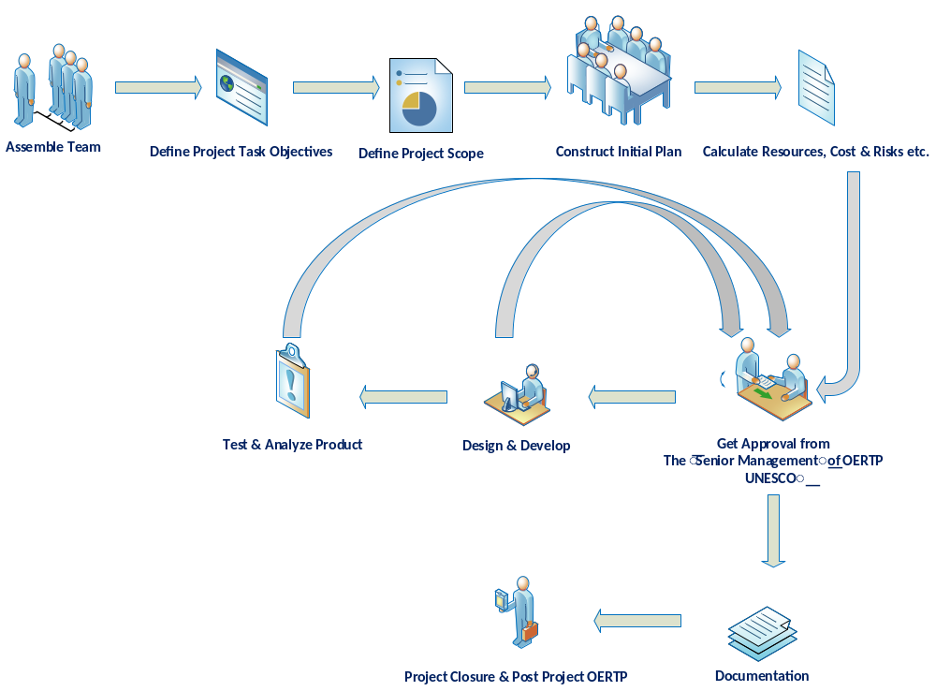 Figure 1. Process Model of OERTP
- The requirements of client are noted and the project is decided with a certain set of objectives.

- The project team is formed and project plan and related documents are created along with team understanding.

- After the approval initial plan of project the development is started and the deliverables are delivered on a timely basis and as the project is reached a stage for initial release then documentation of project is done along with development and the changes are made to the documents as per Configuration Management concurrently.
- The project is divided in 4 phases, which may slightly overlap. The list of deliverables for each phase is described in the Project Deliverables section.

- The list of phases are:

- Design Phase
- Development Phase
- Testing Phase
- Feedback Phase

2.2. Organizational Structure
The organizational structure for the project is shown below:

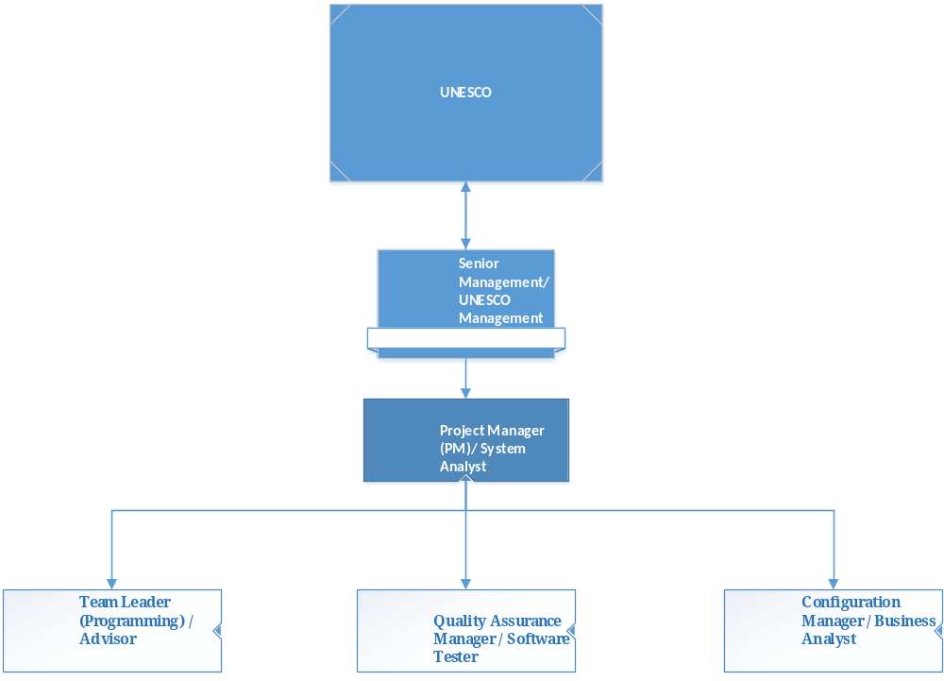 Figure 2. Organizational Structure

2.3. Boundaries and Interfaces
During the project, the OERTP project team interacts with several other groups. These are:
- The SM. Communication to the SM primarily can take place through the PM or in some cases, any team member can directly contact the SM;

- The Advisor. He will attend some weekly meetings and may be consulted for technical advice by every group member.
- The Customer (UNESCO). The SM takes care of the contacts with the customer.

2.4. Project responsibilities
Project Manager/ System Analyst/ Developer
Task: Produce and maintain a project management plan and lead the project according to this plan thus ensuring that the product is delivered on time and as specified in the URD. The PM’s management task includes but is not limited to:
- Motivating team members;
- Forming teams and assigning tasks;
- Checking progress;
- Managing the time budget;
- Defining work packages and goals;
- Providing feedback to the SM through progress reports.
- Coding of the project where ever necessary.
- Configuration Management whenever necessary.
- Working on the software development for the project.

Quality Assurance Manager/ Software Tester / Developer
Task: Guarantee that the product will be delivered as agreed and that it is of good quality. This includes but is not limited to:
- Maintaining the SQAP;
- Verifying that procedures and standards which are defined in the SQAP are adhered to;
- Checking that all project documents are consistent;
- Arranging formal reviews;
- Monitoring and reviewing all testing activities.
- Working on the software development of project.

Configuration Manager / Business Analyst/ Developer
Task: Perform version management for documents and code. This includes but is not limited to:
- Maintaining the SCMP;
- Creating a repository for all documents and code;
- Checking that the repository is used appropriate (that is according to the SCMP) by all team members;
- Maintaining the repository according to the SCMP.
- Working on the software development of project.

Team Leader/ Trainer/ Developer
Task: Perform all necessary activities to ensure that a task assigned to a team is performed well and on time. This includes but is not limited to:
- Planning and coordinating team activities;
- Providing feedback about team progress to the PM;
- Motivating team members;
- Chairing reviews of the items made by his team.
- Training the team in Drupal 6 and 7 framework.
- Working on the software development of project.

Team Member(s) in general:
Task: All the members of the team except the Senior Manager, perform all necessary activities to ensure that a task assigned to a team is performed well and on time. This includes but is not limited to:
- Assisting the TL or PM by signaling problems in an early stage;
- Executing plans made by the TL and by the PM;
- Keeping track of time spent on various tasks;
- Following procedures and plans.

3. Managerial Process

3.1. Objectives and Priorities
The management objective is to deliver the product in time and of high quality. The PM and QAM work together to achieve this by respectively checking that progress is made as planned and monitoring the quality of the product at various stages.

3.2. Assumptions, Dependencies and Constraints
In this project plan, a number of factors are taken into account. For these see chapter 5.5.
Due to the deadline of January 20th 2014, running out of time will have its reflection on the product, and not on the duration of the project. By assigning a priority to every user requirement, a selection can be made of user requirements that may be dropped out if time runs out.

3.3. Risk Management
The risk management process requires your organization to take five key steps:

1. Establish the context – objectives, stakeholders, risk environment.
2. Identify the risks – what can happen? How can it happen?
3. Analyze the risks – likelihood, consequences.
4. Evaluate the risks – priority ratings.
5. Treat the risks – options, responses, plans, controls, measures.

The risk management process also includes communication and consultation with management, staff and stakeholders together with a process of monitoring and review.

The risk management process contained in this procedure aligns with the International Standard for Risk Management (ISO 31000:2009).

The risk management is explained in detail through “SRMP”. The general workflow is based on the risk standard: Risk Management (ISO 31000:2009) structure as shown below:

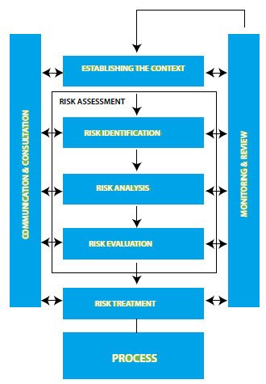
Figure 3 Organizational Structure

3.4. Monitoring and Controlling Mechanisms
The monitoring of progress is done by the PM using the following means:

Weekly Project Group Meetings
The project group meetings take place in the project room. Project group meetings usually take place on Monday at SM’s room, although this time may be subject to change, e‐mails will be send about the time if it changes. These meetings are meant to inform each other of the progress made on various tasks. New tasks are assigned by the PM on these meetings. Before the meeting, all members read minutes of previous meeting. The PM takes care of the agenda and presides the meeting.

Progress Meetings
These meetings are scheduled at-least once in a week on a specified time prior to the meeting. On these meetings the PM and or the TL meet with the SM. Before progress meetings the following things need to be done:
- Write a progress report after the example of the previous reports;
- Read the minutes of the previous meeting;
- Deliver the report to the SM half an hour before the start of the first meeting on that day.

Project metrics
Every week, the work done by the members, needs to be administrated. Each team member has to fill in their hours on a web based log. This log needs to be filled on every Friday. A week starts at Monday and ends at Sunday. Every entry in a log has to belong to one of the following work‐packages:

SPMP, SRMP, SCMP, SQAP, SDDP, SRSP, Prototype, Research, Code, IT, AT, Formal reviews, User Meetings or Presentations.

The PM sends an e‐mail or contacts in person to the SM whenever necessary, regarding different work packages and the hours spend on following categories: Non project related, general project related, documentation, specification, design, Source code, Testing, verification, consolidation and rework. Further, for every work‐ package, an estimation of remaining hours is added.

Team leader meetings
Whenever the PM or SM finds it necessary he can arrange a team leader meeting. Team leader meetings are rather informal and infrequent and the tasks required for one depend on the purpose of the meeting.

3.5 Staff Plan
In the following table, the roles which are distinguished and the person assigned to each role are given. Roles within the group are described in section 3.5.

Role | Name
Senior Management/ Manager (SM) | Davide Storti
Project Manager (PM)/ System Analyst (Programming) | Raj Bharath Adamaram Seshadri
Team Leader (Programming) / Advisor | Denis Pitzalis
Quality Assurance Manager (Quality Analyst) / Software Tester | Qingyun Li
Configuration Manager / Business Analyst | Yasemin Uzuner
Table 2. Staff Plan

The UNESCO employs the SM and the Team Leader. All other persons are members of the OERTP project team.
Communication to the SM is always done by contacting the person directly or through electronic conversation. Only the QAM can contact the SM directly in case he is concerned about the functioning of the PM.

4. Technical Process

4.1. Methods, Tools and Techniques
The methods, tools and techniques used during the course of the project are listed in the SCMP.

4.2. Software Documentation
- During the project, documents should conform to a number of aspects:
- Documents must be of good quality.
- The standards all documents are required to meet are documented in the SCMP with respect to style and in SQAP with respect to content and is reviewed by PM and the SM.

4.3. Project Support Functions
Besides Project Management, three other management functions are present. Below a short description of each of them is given.

4.3.1 Configuration Management
The purpose of software configuration management is to plan, organize, control and coordinate the identification, storage and change of software through development and transfer. ([ESA PSS‐05‐08, Section 2.1]) and [1058-1998 - IEEE]. The PM and CM writes the SCMP in which plans are outlined for performing these tasks.

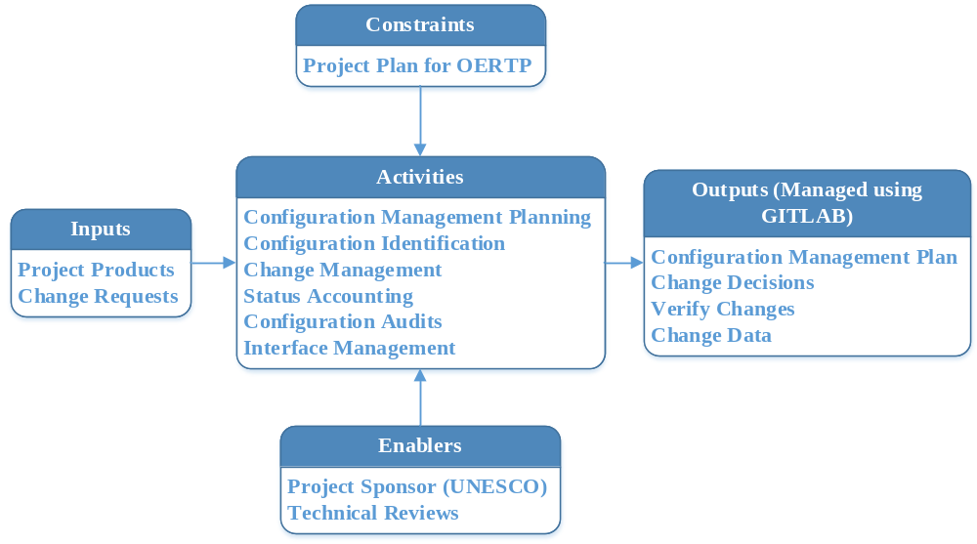 Figure 4. Configuration Management Overview

4.3.2 Quality Assurance
1058-1998 - IEEE and ESA PSS‐05‐0 defines Software Quality Assurance (SQA) as a planned and systematic pattern of all actions necessary to provide adequate confidence that the item or product confirms to established technical requirements.
The QAM outlines plans and procedures needed for performing this task in the SQAP.
Detailed explanation of Quality Assurance is explained Software Quality Assurance Plan document. The Quality Assurance consists of key factors as shown in Error: Reference source not found and explained below:
- Identifying key process: The processes most directly and heavily impacted by those priority factors are the key processes which change impact the quality of a product.
- Identifying key activities: It is essential to identify these activities and individually control them to have better control over the entire process.
- Compliance monitoring: A measurement of compliance is essential to monitor and control these activities.
- Assessing variation: It is essential to assess the variation to understand how far the process has deviated.
- Identifying key parameters: Key parameters are either process measurements that characterize the process, or product measurements that characterize the product.
- Measuring key parameters: Identifying key parameters is done by, various tools and mechanisms such as timesheets for weekly activity reporting, project trackers for schedule tracking, and defect loggers for defect tracking and defect management, are used for this purpose.
- Process control: By taking corrective action, the quantitative measurement of the QA process (compliance rating) and the measurement process (metrics) work together to produce a quality product.
- Escalating: The process through which the stakeholders of the project are informed about the need to take corrective actions for increasing the effectiveness of the product. This is done through publishing the errors in bug tracker and mailing the bugs to the stakeholders and take corrective actions on it.
- Add to knowledge database: All the data associated with Quality Assurance is recorded and analyzed so that new lessons learnt can be to implement in future activities.
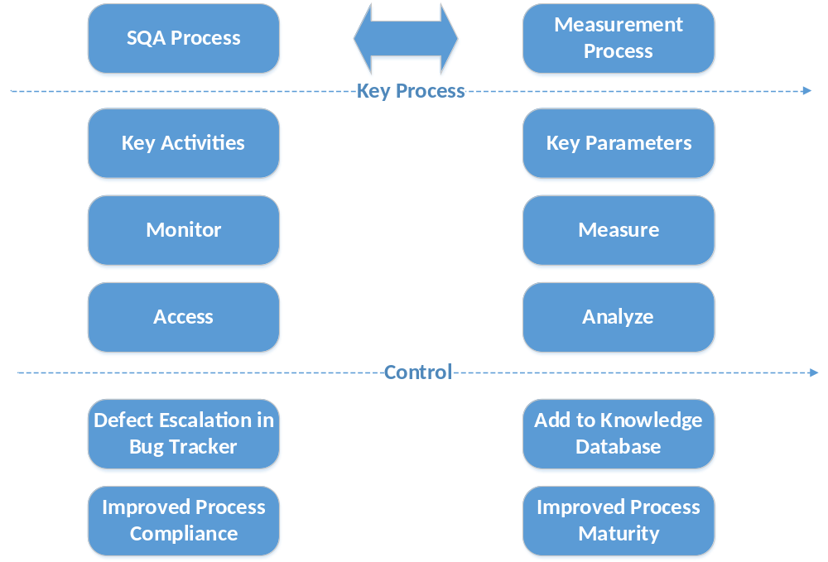
Figure 5. Quality Assurance

5. Work packages, Schedule, Budget

5.1. Work packages
The work packages are prescribed by the SM. All work packages with their managers and estimated time are explained in detail using Gantt chart in Appendix E and the Work Breakdown Structure in Appendix F.

The chart below shows how the work has and to be carried out. On X- axis is the deliverables and on Y-axis the number of days

At the beginning of the project both: Remaining Work and the Work (actual) are the same.

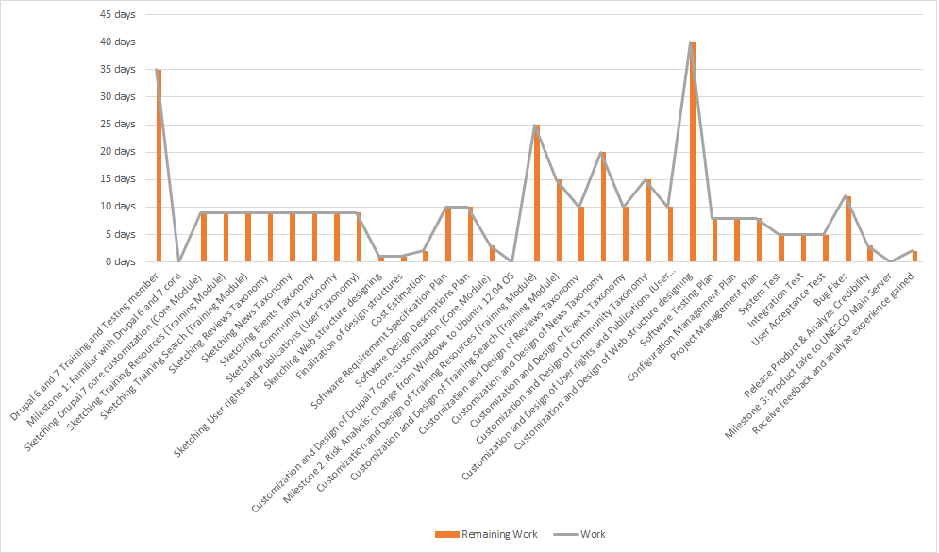

Figure 6. Graphical view of work packages in reference to number of days.

5.3. Resource Requirements
The most important resources during the project are human resources and resources used for development of the software application. An overview of resource utilization during the various project phases is given in section 5.4. Other resources needed include development stations, a server where documents and information can be stored, a printer, network connectivity, a working and meeting room with sufficient tables and chairs and a telephone. During the project software is required. For example a programming language and a text editor are necessary. SCMP describes the software that is used during the project.

Resource Stats
The below chart shows availability of each work resource.
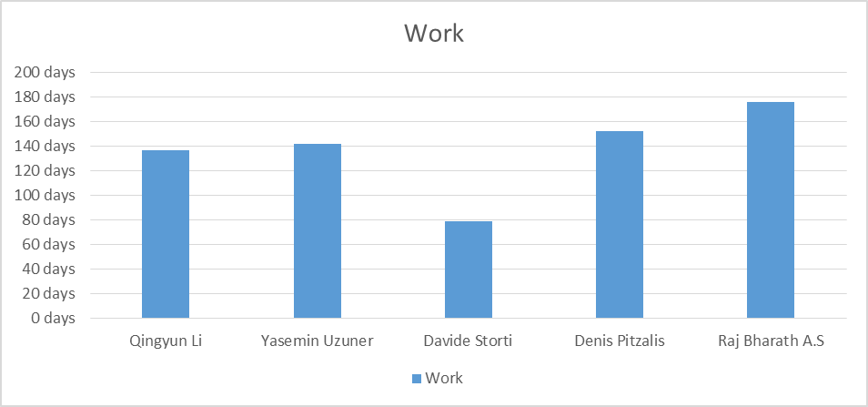
Figure 7. Graphical view of availability of each work resource

5.4. Budget and Resource Allocation
The average wage for a professional as per UNESCO norms is € 3500 per month and since all members of the project team are professionals, hence the calculation would have an average of € 20 per hour for each individual based on intensity of work involved and also including the expenses renting of computers, internet, necessary stationary and a tangible environment to work etc.

Based on records, an estimated average expenses for using UNESCO premises for each individual per month is: (For example, computers, internet, necessary stationary and a tangible environment to work etc.) = 547.2 € per person.

The cost has been estimated based on the work activities as shown in the Work Breakdown Structure in Appendix F. Each point is a deliverable in the work breakdown structure and based on the amount of activity and complexity involved each deliverable is rated a given “Weightage” and the budget is estimated based on the weightage. The weightage of each deliverable is done by PM and SM. The weightage for each deliverable ranges from 1 to 5.
The weightage and the amount for each weightage is shown below,
Weightage, W | Percentage (%), P | Amount in Euros (€) per hour | Amount in Euros (€) per day per person  (Each working day has 8 hours)
5 | 150 | 20 * 150% = 30 € | 30 * 8 = 240 €
4 | 100 | 20 * 100% = 20 € | 20 * 8 = 160 €
3 | 80 | 20 * 80% = 16 € | 16 * 8 = 128 €
2 | 60 | 20 * 60% = 12 € | 12 * 8 = 96 €
1 | 40 | 20 * 40% = 8 € | 8* 8 = 64€
Table 3. Budget-Task Weightage

Formula for calculation budget:

Total amount for a deliverable =
(Amount in Euros (€) per day with respect to given Weightage for that deliverable) *
(Number of Responsible Members involved in the deliverable) *
(Number of days assigned to complete that deliverable)
For example,
Total amount for “Drupal 6 and 7 Training and Testing member” => (16* 8) * (1) * (35) => (128* 35) = € 4480.

Based on the above table, work breakdown structure and the formation of Gantt chart the budget is calculated for the project

For each phase as described in this SPMP, a budget has been estimated based on the word breakdown structure as shown in the Appendix A

This budget is extended by the availability of:
- A sufficiently furnished workroom;
- A printer supplied by UNESCO;
- A white board (plus white board markers);
- 5 (relatively fast) development computers;
- A server to support CM tasks;

Furthermore in the appendices a detailed phase budget is given for each phase.

Total Estimated Cost = 119, 760.00 €

Task Name | Duration | Weightage | Total cost assigned to each deliverable
Drupal 6 and 7 Training and Testing member | 35 days | 3 | 4,480.00 €
Milestone 1: Familiar with Drupal 6 and 7 core
Sketching Drupal 7 core customization (Core Module) | 9 days | 2 | 4,320.00 €
Sketching Training Resources (Training Module) | 9 days | 2 | 4,320.00 €
Sketching Training Search (Training Module) | 9 days | 2 | 4,320.00 €
Sketching Reviews Taxonomy | 9 days | 2 | 4,320.00 €
Sketching News Taxonomy | 9 days | 2 | 4,320.00 €
Sketching Events Taxonomy | 9 days | 2 | 4,320.00 €
Sketching Community Taxonomy | 9 days | 2 | 4,320.00 €
Sketching User rights and Publications (User Taxonomy) | 9 days | 2 | 4,320.00 €
Sketching Web structure designing | 1 day | 2 | 4,320.00 €
Finalization of design structures | 1 day | 2 | 4,320.00 €
Cost Estimation | 2 days | 4 | 320.00 €
Software Requirement Specification Plan | 10 days | 4 | 4,800.00 €
Software Design Descriptions Plan | 10 days | 4 | 4,800.00 €
Customization and Design of Drupal 7 core customization (Core Module) | 3 days | 5 | 720.00 €
Milestone 2: Risk Analysis: Change from Windows to Ubuntu 12.04 OS
Customization and Design of Training Resources (Training Module) | 25 days | 4 | 4,000.00 €
Customization and Design of Training Search (Training Module) | 15 days | 4 | 2,400.00 €
Customization and Design of Reviews Taxonomy | 10 days | 4 | 1,600.00 €
Customization and Design of News Taxonomy | 10 days | 4 | 1,600.00 €
Customization and Design of Events Taxonomy | 10 days | 4 | 1,600.00 €
Customization and Design of Community Taxonomy | 15 days | 4 | 2,400.00 €
Customization and Design of User rights and Publications (User Taxonomy) | 10 days | 4 | 1,600.00 €
Customization and Design of Web structure designing | 10 days | 5 | 7,200.00 €
Software Testing Plan | 8 days | 4 | 1,280.00 €
Configuration Management Plan | 8 days | 4 | 1,280.00 €
Project Management Plan + Risk Management Plan | 8 days | 4 | 1,280.00 €
System Test | 5 days | 3 | 640.00 €
Integration Test | 5 days | 4 | 3,200.00 €
User Acceptance Test | 5 days | 3 | 3,200.00 €
Bug Fixes | 3 days | 4 | 1,920.00 €
Release product, Analyze credibility and Experience gained through the project. | 3 days | 3 | 1,920.00 €
Milestone 3: Product take to UNESCO Main Server
Receive feedback | 2 days | 1 | 640.00 €
Total cost for work involved |  |  | 96, 080 €
Estimated average expenses for using UNESCO premises (547.2 €) for all 5 members in the OERTP team for an average 5 months = 547.2 * 5 * 5 = 13,680 € |  |  | 13,680 €
Potential Risk liabilities : based on UNESCO’s experience |  |  | 10,000 €
Total cost (in Euros, €) |  |  | 119, 760 €
Table 4. Budget of OERTP

The below graph shows the cost estimate based on the progress of work. This, helps in determining actual cash flow occurring as the project gets completed.

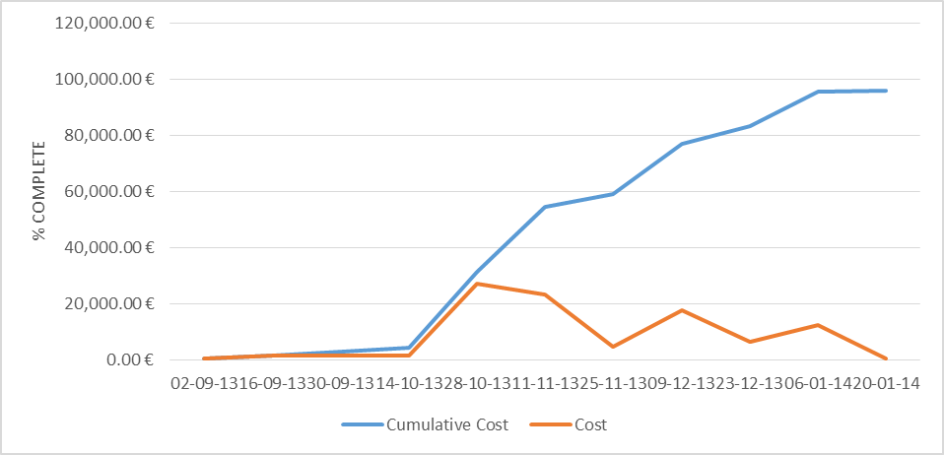
Figure 8. Predicting Cumulative Cost along with Cost spending through time

Cost Status
Cost status for work resources.
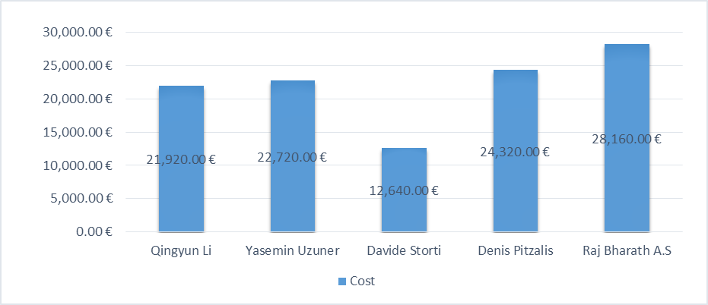
Figure 9. Gaphical representation of cost expenditure for each individual in OETP team

Name | Actual Work | Cost
Qingyun Li | 137 days | 21,920.00 €
Yasemin Uzuner | 142 days | 22,720.00 €
Davide Storti | 79 days | 12,640.00 €
Denis Pitzalis | 152 days | 24,320.00 €
Raj Bharath A.S | 176 days | 28,160.00 €

Table 5. Cost expenditure for each individual in OETP team

5.5 Schedule
The schedule of OERTP project is shown through Gantt chart in Appendix E if any discrepancy or insufficiency of time to finish a task is compensated by working on the weekends or overtime as per the responsible designations involved in the tasks.

Appendix A: Design Phase
The Design phase can be called the problem definition phase. User requirements are documented, giving the customers view of the problem. The main outputs of the Design phase are the:
- Scope definition of project
- Work Breakdown Structure
- Cost Estimation
- Risk Management

Appendix B: Development Phase
In the Development phase the main focus is on developing/coding the software requirements. Besides development the management documents are modified.

Appendix C: Testing Phase
In the Testing phase the main focus is on the testing the efficiency of the components of the product and the interaction between those components. A detailed process of testing is explained in SQAP.

Appendix E: Gantt chart
Task Name | Duration | Start | Deadline | Responsible Members
Drupal 6 and 7 Training and Testing member | 35 days | Thu 12-09-19 | Wed 30-10-19 | Denis Pitzalis
Milestone 1: Familiar with Drupal 6 and 7 core
Sketching Drupal 7 core customization (Core Module) | 9 days | Thu 31-10-19 | Tue 12-11-19 | Davide Storti,Denis Pitzalis,Qingyun Li,Raj Bharath A.S,Yasemin Uzuner
Sketching Training Resources (Training Module) | 9 days | Thu 31-10-19 | Tue 12-11-19 | Davide Storti,Denis Pitzalis,Qingyun Li,Raj Bharath A.S,Yasemin Uzuner
Sketching Training Search (Training Module) | 9 days | Thu 31-10-19 | Tue 12-11-19 | Davide Storti,Denis Pitzalis,Qingyun Li,Raj Bharath A.S,Yasemin Uzuner
Sketching Reviews Taxonomy | 9 days | Thu 31-10-19 | Tue 12-11-19 | Davide Storti,Denis Pitzalis,Qingyun Li,Raj Bharath A.S,Yasemin Uzuner
Sketching News Taxonomy | 9 days | Thu 31-10-19 | Tue 12-11-19 | Davide Storti,Denis Pitzalis,Qingyun Li,Raj Bharath A.S,Yasemin Uzuner
Sketching Events Taxonomy | 9 days | Thu 31-10-19 | Tue 12-11-19 | Davide Storti,Denis Pitzalis,Qingyun Li,Raj Bharath A.S,Yasemin Uzuner
Sketching Community Taxonomy | 9 days | Thu 31-10-19 | Tue 12-11-19 | Davide Storti,Denis Pitzalis,Qingyun Li,Raj Bharath A.S,Yasemin Uzuner
Sketching User rights and Publications (User Taxonomy) | 9 days | Thu 31-10-19 | Tue 12-11-19 | Davide Storti,Denis Pitzalis,Qingyun Li,Raj Bharath A.S,Yasemin Uzuner
Sketching Web structure designing | 1 day | Wed 13-11-19 | Wed 13-11-19 | Davide Storti,Denis Pitzalis,Qingyun Li,Raj Bharath A.S,Yasemin Uzuner
Finalization of design structures | 1 day | Thu 14-11-19 | Thu 14-11-19 | Davide Storti,Denis Pitzalis,Qingyun Li,Raj Bharath A.S,Yasemin Uzuner
Cost Estimation | 2 days | Thu 14-11-19 | Fri 15-11-19 | Raj Bharath A.S
Software Requirement Specification Plan | 10 days | Thu 14-11-19 | Wed 27-11-19 | Qingyun Li,Raj Bharath A.S,Yasemin Uzuner
Software Design Descriptions Plan | 10 days | Thu 14-11-19 | Wed 27-11-19 | Qingyun Li,Raj Bharath A.S,Yasemin Uzuner
Customization and Design of Drupal 7 core customization (Core Module) | 3 days | Thu 28-11-19 | Mon 02-12-19 | Raj Bharath A.S
Milestone 2: Risk Analysis: Change from Windows to Ubuntu 12.04 OS
Customization and Design of Training Resources (Training Module) | 25 days | Sat 07-12-19 | Thu 09-01-20 | Raj Bharath A.S
Customization and Design of Training Search (Training Module) | 15 days | Sat 07-12-19 | Thu 26-12-19 | Raj Bharath A.S
Customization and Design of Reviews Taxonomy | 10 days | Sat 07-12-19 | Thu 19-12-19 | Yasemin Uzuner
Customization and Design of News Taxonomy | 10 days | Sat 07-12-19 | Thu 19-12-19 | Denis Pitzalis
Customization and Design of Events Taxonomy | 10 days | Sat 07-12-19 | Thu 19-12-19 | Qingyun Li
Customization and Design of Community Taxonomy | 15 days | Sat 07-12-19 | Thu 26-12-19 | Yasemin Uzuner
Customization and Design of User rights and Publications (User Taxonomy) | 10 days | Sat 07-12-19 | Thu 19-12-19 | Denis Pitzalis
Customization and Design of Web structure designing | 10 days | Sat 07-12-19 | Thu 19-12-19 | Yasemin Uzuner,Denis Pitzalis,Qingyun Li
Final updated version of Quality Assurance Plan | 8 days | Thu 26-12-19 | Mon 06-01-20 | Raj Bharath A.S
Final updated version of Configuration Management Plan | 8 days | Thu 26-12-19 | Mon 06-01-20 | Raj Bharath A.S
Final updated version of Project Management Plan + Software Risk Management Plan | 8 days | Thu 26-12-19 | Mon 06-01-20 | Raj Bharath A.S
System Test | 5 days | Tue 07-01-20 | Mon 13-01-20 | Qingyun Li
Integration Test | 5 days | Tue 07-01-20 | Mon 13-01-20 | Denis Pitzalis,Qingyun Li,Raj Bharath A.S,Yasemin Uzuner
User Acceptance Test | 5 days | Tue 07-01-20 | Mon 13-01-20 | Qingyun Li,Davide Storti,Denis Pitzalis,Raj Bharath A.S,Yasemin Uzuner
Bug Fixes | 3 days | Tue 14-01-20 | Thu 16-01-20 | Denis Pitzalis,Qingyun Li,Raj Bharath A.S,Yasemin Uzuner
Release product, Analyze credibility and Experience gained through the project. | 3 days | Tue 14-01-20 | Thu 16-01-20 | Davide Storti,Denis Pitzalis,Qingyun Li,Raj Bharath A.S,Yasemin Uzuner
Milestone 3: Product take to UNESCO Main Server
Receive feedback | 2 days | Fri 17-01-20 | Mon 20-01-20 | Davide Storti,Denis Pitzalis,Qingyun Li,Raj Bharath A.S,Yasemin Uzuner
Table 6. Gantt chart (Schedule)

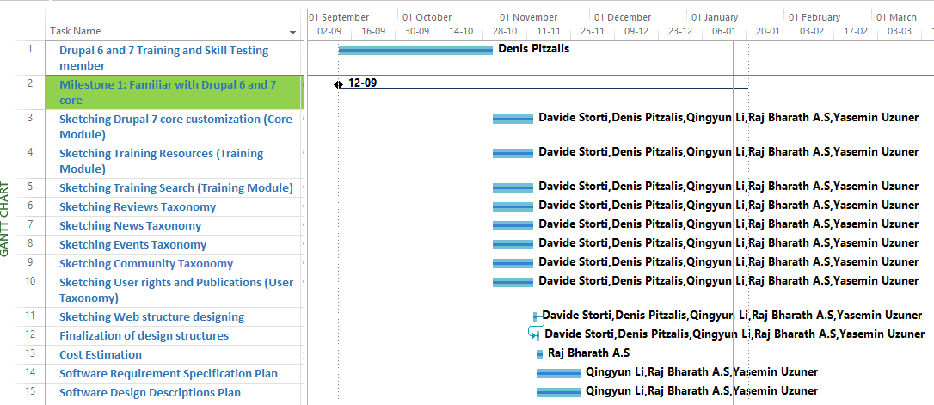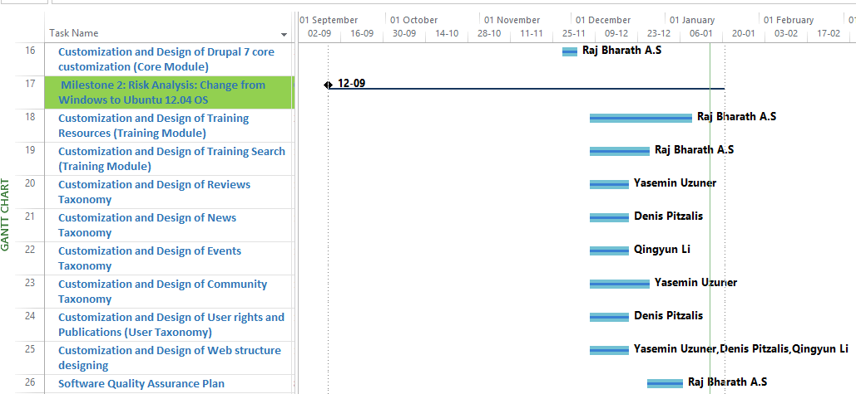

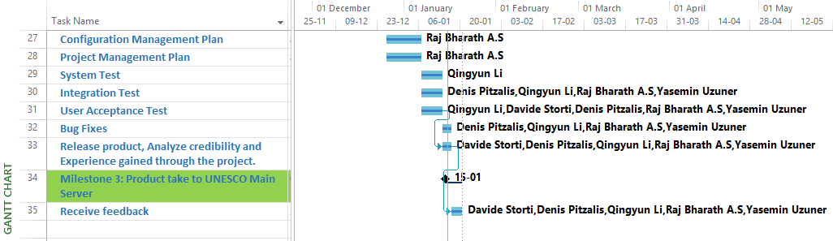

Figure 10. Gantt chart of OERTP.

Appendix F: Work Breakdown Structure
The below structure shows the Work Breakdown Structure for OERTP project:

- Open Educational Resources Training Platform
  - Initial Plan
    - Drupal 7 core customization (Core Module)
    - Training Resources (Training Module)
    - Training Search (Training Module)
    - Reviews Taxonomy
    - News Taxonomy
    - Events Taxonomy
    - Community Taxonomy
    - User rights and Publications (User Taxonomy)
    - Web structure designing

  - Initial Infrastructure (Time and Cost Evaluation)
    - Drupal core customization
      - Calculate man hours for Developing Core Module (Man Hours Estimation etc.)
      - Determine and assign time based on Man-Hours
      - Assign cost based on Man Hours Estimation

    - For Training (including “Search” option) Module
      - Calculate man hours for Training Module (Man-Hours Estimation etc.)
      - Determine and assign time based on Man-Hours
      - Assign cost based on Man-Hours Estimation

    - Reviews Taxonomy
      - Calculate man hours for Reviews Taxonomy (Man-Hours Estimation etc.)
      - Determine and assign time based on Man-Hours
      - Assign cost based on Man-Hours Estimation

    - News Taxonomy
      - Calculate man hours for News Taxonomy (Man-Hours Estimation etc.)
      - Determine and assign time based on Man-Hours
      - Assign cost based on Man-Hours Estimation

    - Events Taxonomy
      - Calculate man hours for Events Taxonomy (Man-Hours Estimation etc.)
      - Determine and assign time based on Man-Hours
      - Assign cost based on Man-Hours Estimation

    - Community Taxonomy
      - Calculate man hours for Community Taxonomy (Man-Hours Estimation etc.)
      - Determine and assign time based on Man-Hours
      - Assign cost based on Man-Hours Estimation

    - User Taxonomy
      - Calculate man hours for User Taxonomy (Man-Hours Estimation etc.)
      - Determine and assign time based on Man-Hours
      - Assign cost based on Man-Hours Estimation

    - Web structure designing
      - Calculate man hours for User Taxonomy (Man-Hours Estimation etc.)
      - Determine and assign time based on Man-Hours
      - Assign cost based on Man-Hours Estimation

    - Overall Estimation

  - Initial Product Requirements
    - Drupal Core Module Time Box
      - Design
        - Web Front- End
        - Interfaces

      - Develop
        - Code
        - Integration

      - Review
        - System - Integration Test
        - User Acceptance Test
        - Overall Performance & Compatibility Test of Project

    - Training Module (including “Search” option) Time Box
      - Design
        - Web Front- End
        - SQL Database
        - Interfaces

      - Develop
        - Code
        - Integration

      - Review
        - System - Integration Test
        - User Acceptance Test
        - Overall Performance & Compatibility Test of Project

    - Reviews Taxonomy Time Box
      - Design
        - Web Front- End
        - Interfaces

      - Develop
        - Code
        - Integration

      - Review
        - System - Integration Test
        - User Acceptance Test
        - Overall Performance & Compatibility Test of Project

    - News Taxonomy Time Box
      - Design
        - Web Front- End
        - Interfaces

      - Develop
        - Code
        - Integration

      - Review
        - System - Integration Test
        - User Acceptance Test
        - Overall Performance & Compatibility Test of Project

    - Events Taxonomy Time Box
      - Design
        - Web Front- End
        - Interfaces

      - Develop
        - Code
        - Integration

      - Review
        - System - Integration Test
        - User Acceptance Test
        - Overall Performance & Compatibility Test of Project

    - Community Taxonomy Time Box
      - Design
        - Web Front- End
        - Interfaces

      - Develop
        - Code
        - Integration

      - Review
        - System - Integration Test
        - User Acceptance Test
        - Overall Performance & Compatibility Test of Project

    - User Taxonomy Time Box
      - Design
        - Web Front- End
        - Interfaces

      - Develop
        - Code
        - Integration

      - Review
        - System - Integration Test
        - User Acceptance Test
        - Overall Performance & Compatibility Test of Project

    - Web designing Time Box
      - Design
        - Web Front- End
        - Interfaces

      - Develop
        - Code
        - Integration

      - Review
        - System - Integration Test
        - User Acceptance Test
        - Overall Performance & Compatibility Test of Project

  - Project Documentation
    - Assemble Tech Specs
    - Develop System Flowcharts
    - Deliver Source Code
    - Complete System Documentation Manual

  - Project Closure
    - Handing over operations
    - Tying up loose ends
    - Educating the user about product

  - Post-Project
    - Check if the product met the business needs
    - Reviewing the project and experience gained from it.

Appendix G: Change log history
Please refer to Configuration Manager as the change history is regularly updated in “GitLab” Configuration Manager Application.

